DIS-US-Natick Manitou Grave stones-Natick Public Library

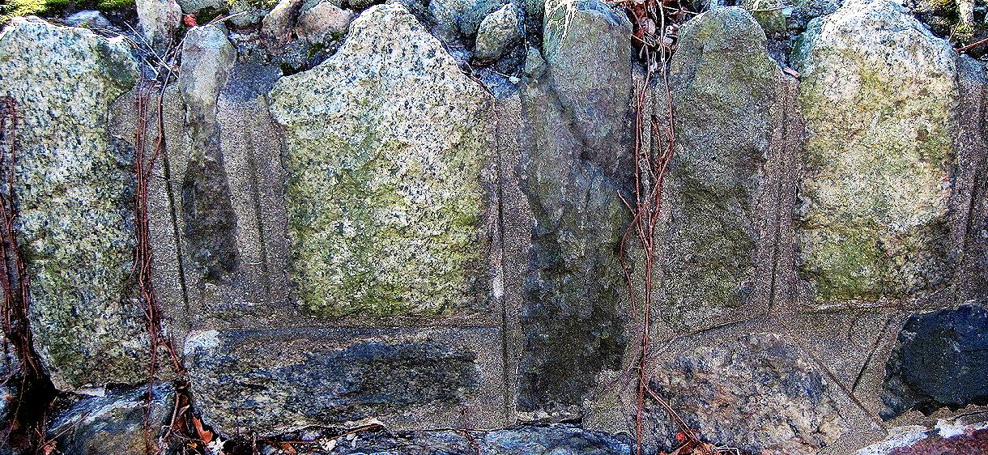

Manitou Gravesstones 1-6- Natick Public Library

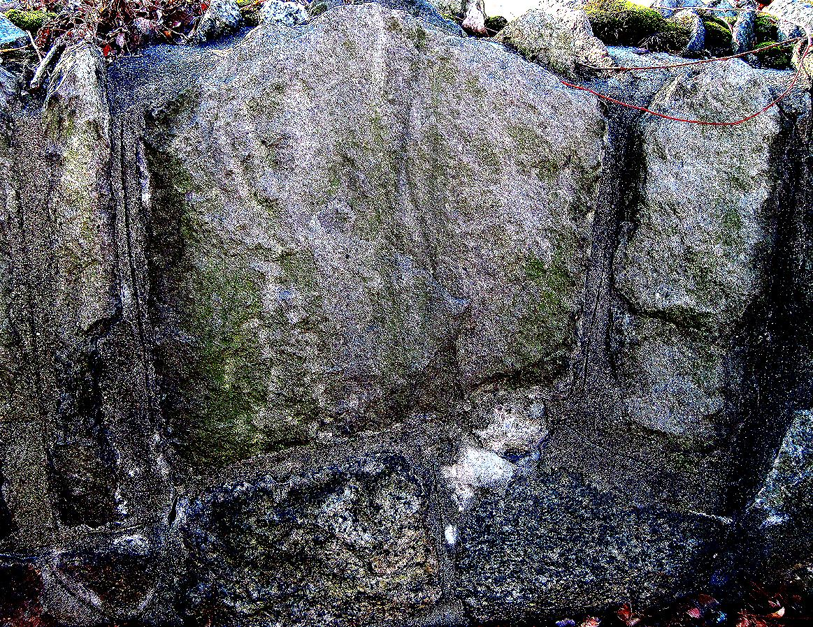

Manitou Gravesstones 7-9- Natick Public Library

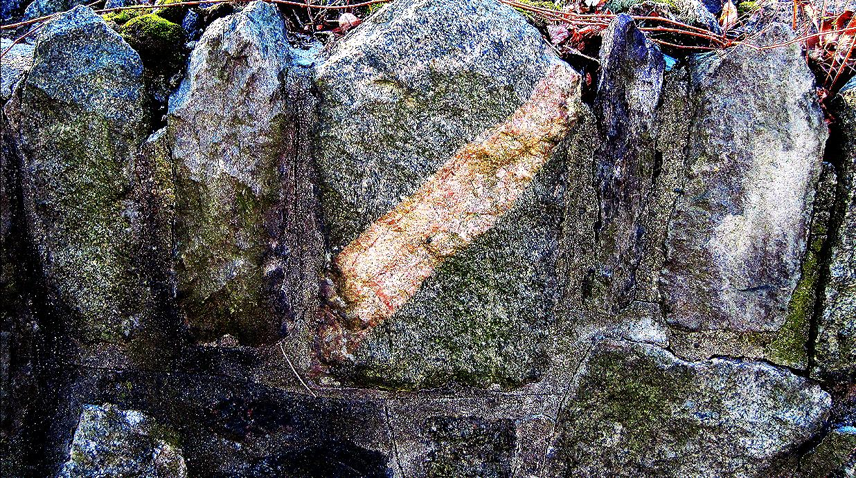

Manitou Gravesstones 10-14- Natick Public Library

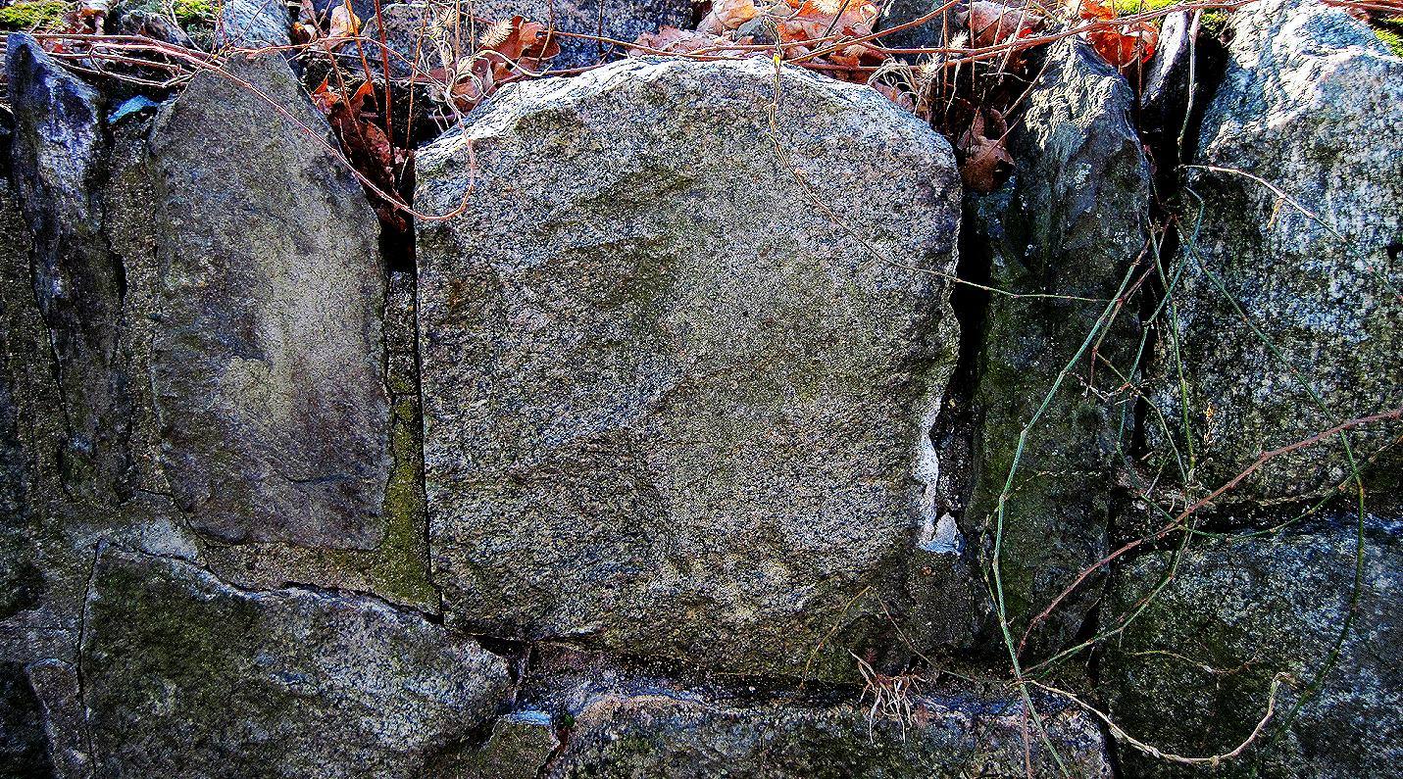

Manitou Gravesstones 15-19- Natick Public Library

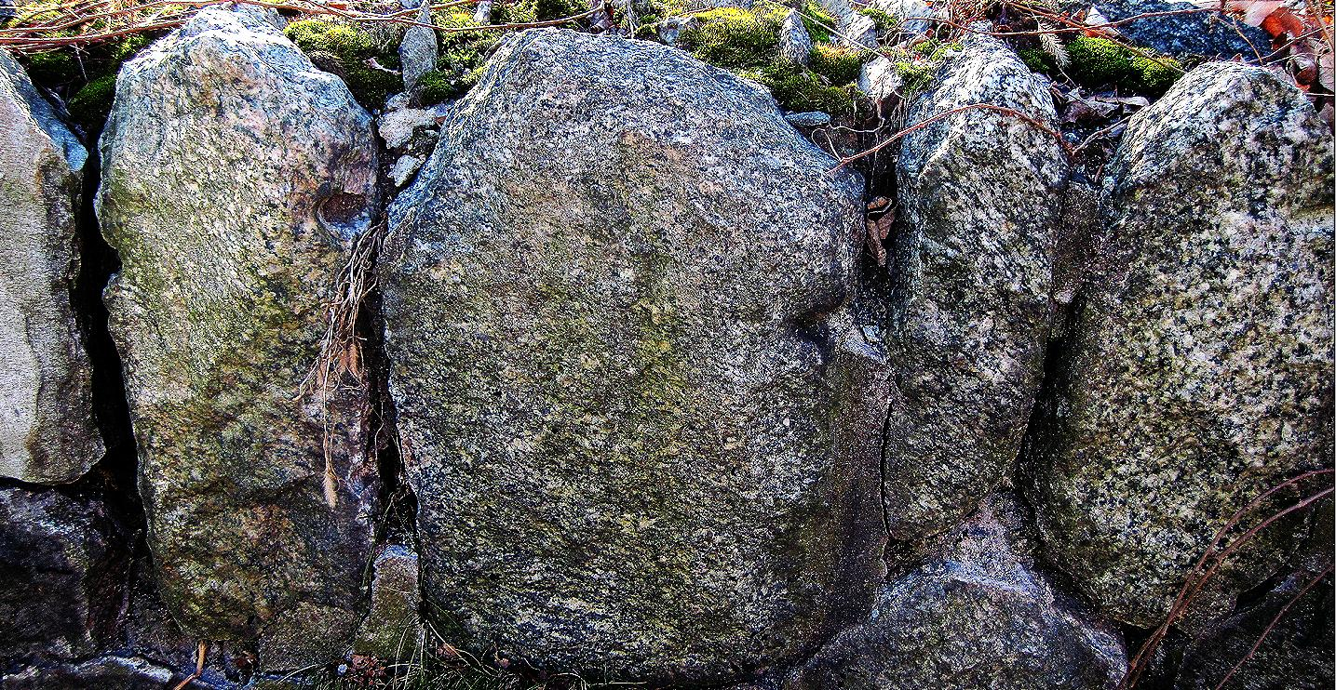

Manitou Gravesstones 20-24- Natick Public Library

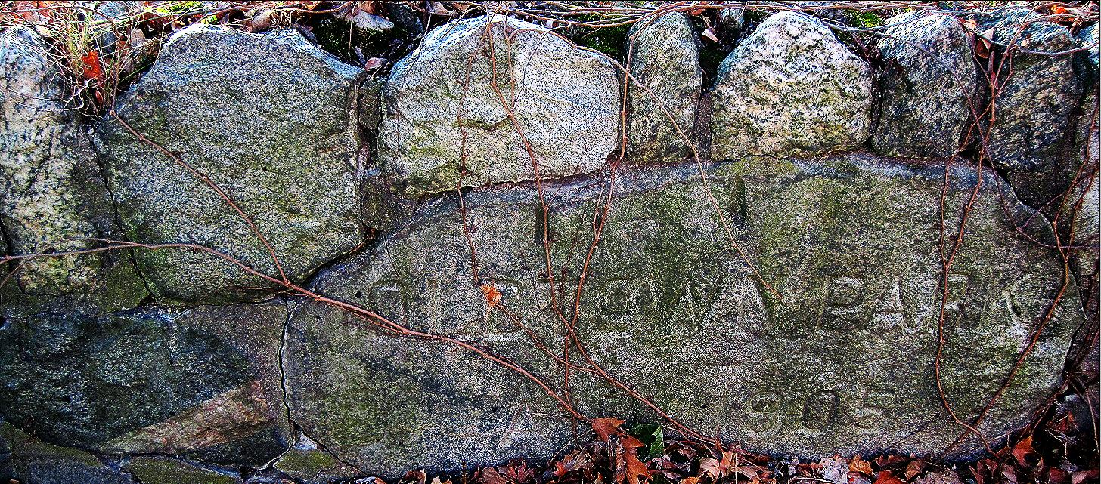

Manitou Gravesstones 25-31- Natick Public Library. "OLD TOWN PARK/ ANNO 1905"

